# IT 451- Computer Organization and Architecture LAB

Assignment 3­­­

*ISE Design Suite has been used for the simulation and synthesis of the design. VHDL is used as the hardware description language.*

**Suprotik Dey**

**IT 4th Semester**

**Roll: Hx 31**

**510815050**

1. **Question:**

**Design and simulate 8 bit unsigned binary multiplier.**

**VHDL Code:**

library IEEE;

use IEEE.STD_LOGIC_1164.ALL;

use ieee.std_logic_arith.all;

use ieee.std_logic_unsigned.all;

entity unsignedMultiCkt is

Port ( MultiplicandIn : in STD_LOGIC_VECTOR (7 downto 0);

MultiplierIn : in STD_LOGIC_VECTOR (7 downto 0);

ResultOut : out STD_LOGIC_VECTOR (15 downto 0));

end unsignedMultiCkt;

architecture Behavioral of unsignedMultiCkt is

begin

process(MultiplicandIn, MultiplierIn)

variable Acc : std_logic_vector(8 downto 0);

variable product_reg : std_logic_vector(23 downto 0);

begin

Acc := '0' & MultiplicandIn;

product_reg := "0000000000000000" & MultiplierIn;

-- algorithm is to repeat shifting/adding

for i in 1 to 8 loop

if product_reg(0)='1' then

product_reg(23 downto 9) := product_reg(23 downto 9)

+ Acc;

end if;

product_reg(23 downto 0) := '0' & product_reg(23 downto 1);

end loop;

ResultOut <= product_reg(16 downto 1);

end process;

end Behavioral;

**RTL template:**

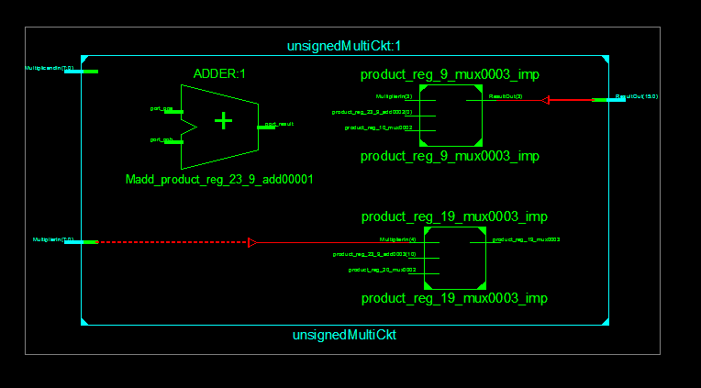

**Test Bench Code:**

LIBRARY ieee;

USE ieee.std_logic_1164.ALL;

ENTITY multitest IS

END multitest;

ARCHITECTURE behavior OF multitest IS

-- Component Declaration for the Unit Under Test (UUT)

COMPONENT unsignedMultiCkt

PORT(

MultiplicandIn : IN std_logic_vector(7 downto 0);

MultiplierIn : IN std_logic_vector(7 downto 0);

ResultOut : OUT std_logic_vector(15 downto 0)

);

END COMPONENT;

--Inputs

signal MultiplicandIn : std_logic_vector(7 downto 0) := (others => '0');

signal MultiplierIn : std_logic_vector(7 downto 0) := (others => '0');

--Outputs

signal ResultOut : std_logic_vector(15 downto 0);

BEGIN

-- Instantiate the Unit Under Test (UUT)

uut: unsignedMultiCkt PORT MAP (

MultiplicandIn => MultiplicandIn,

MultiplierIn => MultiplierIn,

ResultOut => ResultOut

);

-- Stimulus process

stim_proc: process

begin

MultiplicandIn <= "00000100";

MultiplierIn <= "00000011";

wait;

end process;

END;

**Output:**

